A presentation of the Ebando association

The Ebando association came into existence in 1981 under the name ASSOCIATION FOR AGRICULTURAL and CULTURAL PROMOTION of GABONESE VILLAGE (APACVIGABON). Since 1999 it’s been renamed and is now known as NATURE CULTURE FUTURE EBANDO ASSOCIATION. It's chairman is Papa André NGIE OVONO, and it's main Director is Hugues Obiang Poitevin.

Activities

Cultural Eco-tourism
The association opens the doors of Gabon to Westerners in many ways:
- Rituals: performed by Ebando members on association's location, it is both a tremendous discovery for visitors, and a strong social inclusion tool for young members of the association who can get income while practicing their culture.
- Handcraft: Ebando supports local handcraft buying Gabonese villages’ craft products above the usual rate. Other handcraft support initiatives are in the pipeline.
- Human resources: Naturopaths, foresters, musicians, guides... Ebando places its address book at curious travelers’ disposal…
- 4x4s: Hugues Obiang Poitevin was a lorry driver in Gabon for several years. He is well known from many villages’ inhabitants. He is an excellent guide, and has worked with numerous TV crews (BBC…) when filming Gabonese wildlife and culture.

Social
Ebando feeds, houses and educates between 10 and 15 young Gabonese, most of them abandoned by their families. Ebando is particularly aware of the fate of young women, who usually lack income or education and turn to prostitution…

Projects set up
Ebando seeks new strategies for the development of Gabon… plantations, eco-cultural villages, youth training to traditional craft techniques. Many projects are being developed, and Ebando should soon give birth to many daughter-associations in the Gabonese hinterland…
Accounts analysis
FOR EXAMPLE, from MAY to November 2009, Ebando gathered and spent about
23 500€. Most of this income came from rituals organised for visitors.
Here are the percentages of how our association spent this money:

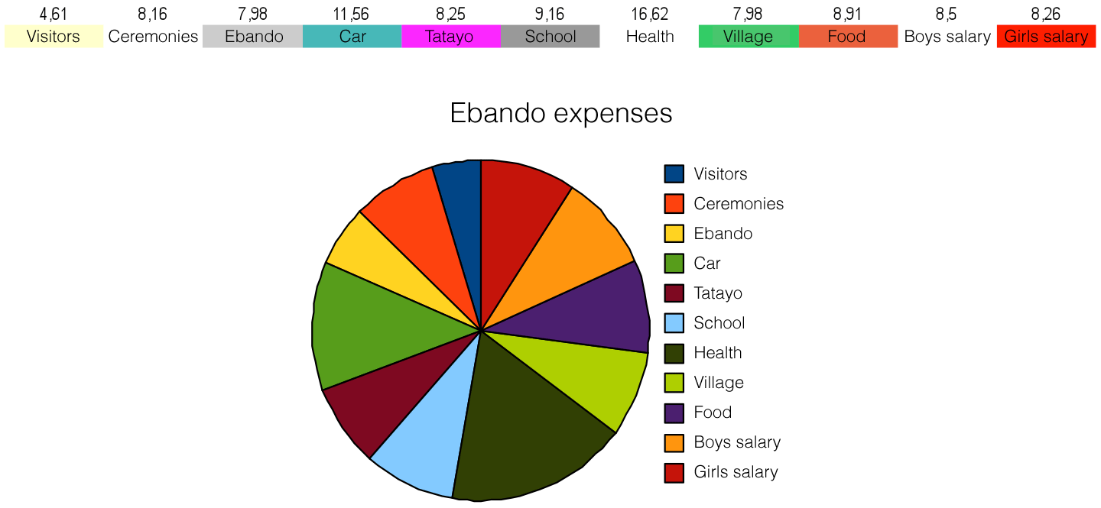As seen above, health, school, food, pocket money and premises' maintenance bear more than half of expenses ; cost of organizing ceremonies and visitors's reception being fairly low in comparison.
More than 18% of expenditures are shared between young Ebando workers.
Subsequently, largest expenses concern healthcare (17%) and vehicle maintenance (12%).
In detail :
Descriptions of different expenditure categories :
Visitors : Expenses regarding housing, feeding for visitors who came to participate in ceremonies (4,5%)
Ceremonies : Actual ceremonies cost (8%)
Ebando : Running cost, specific investments: Raffia weaving workshops, handcraft purchase (harps, objects of worship…) (8%)
Car : 4x4 maintenance cost to help taking visitors to remote villages… (12%)
Tatayo (Hugues O.P) : Communication expenses (internet plan, photocopies, telephone) and friendly relations expenses (8%)
School : Ebando youth education (9 %)
Health : Medical care provided to members of the association (17%)
Village : Premises maintenance, running costs (gaz, electricity…) (8%)
Food : Approximatively 20 people are fed by the association... (9 %)
Girls & boys salaries : On top of scholarship, housing and food, Ebando gives pocket money to young members of the association. (18%)

A WORD TO THE WISE IS ENOUGH!

